ReactJS Hands-on 4 - Component Lifecycle (Blog App)

Project Structure
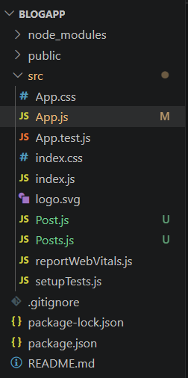

Post.js
class Post {
constructor(id, title, body) {
this.id = id;
this.title = title;
this.body = body;
}
}
export default Post;

Posts.js
import React from "react";
import Post from "./Post";
class Posts extends React.Component {
constructor(props) {
super(props);
this.state = { posts: [] };
}
loadPosts() {
fetch("https://jsonplaceholder.typicode.com/posts")
.then(response => response.json())
.then(data => {
const posts = data.map(
item => new Post(item.id, item.title, item.body)
);
this.setState({ posts });
});
}
componentDidMount() {
this.loadPosts();
}
render() {
return (
<div>
<h1>Blog Posts</h1>
{this.state.posts.map(post => (
<div key={post.id}>
<h2>{post.title}</h2>
<p>{post.body}</p>
<hr />
</div>
))}
</div>
);
}
componentDidCatch(error, info) {
alert(error);
}
}
export default Posts;

App.js
import Posts from "./Posts";
function App() {
return (
<div>
<Posts />
</div>
);
}
export default App;

Expected Output
Blog Posts page displaying blog titles and bodies fetched from https://jsonplaceholder.typicode.com/posts.
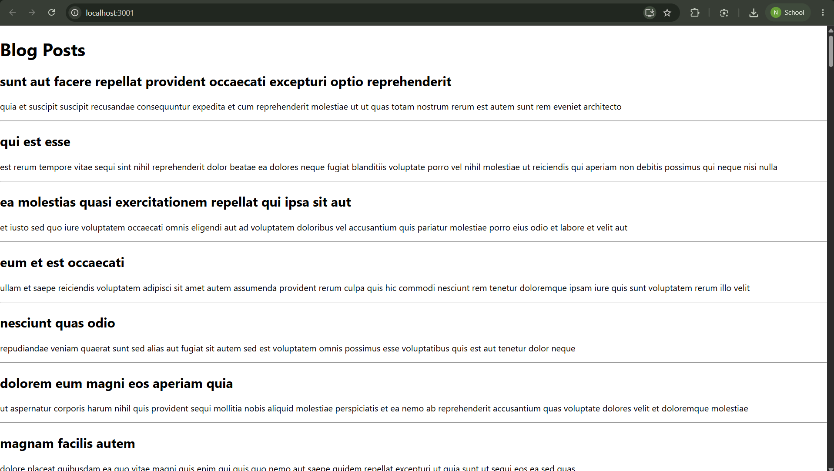

Result
The Blog application was created successfully. The posts were fetched using componentDidMount(), displayed in the browser, and errors are handled using componentDidCatch().

